 | SIMATS ENGINEERING  Department of Computer Science and Engineering  CSA15 Cloud Computing and Big Data Analytics  CO2 AT2 - VM Configuration and Security Evidence Workbook  Guided practical workbook for Azure VM, local VM, Docker container, security checks, recovery evidence and GitHub submission
Assessment Metadata
Course Code | CSA15
Course Title | Cloud Computing and Big Data Analytics
Assessment | CO2 AT2 - VM Configuration and Security Evidence
Submission Type | Individual digital workbook based on the same capstone title used in CO1 and CO2 AT1
Faculty | Dr C. Rajesh Babu
Employee ID | SSETSCS415
Submission Mode | Completed workbook, evidence screenshots and GitHub repository link through Google Classroom
How This Workbook Works
- Use the same capstone title carried from CO1 and CO2 AT1.
- Read each procedure block, perform the action, verify the checkpoint and then fill the response table.
- Use Azure first when account activation is available. Use the local VM path when Azure is blocked. Use Docker for container comparison. Use simulation only when practical deployment is blocked.
- Screenshots must show the student's actual configuration or verified simulation work. Hide credentials, keys, tokens and sensitive account details.
- Upload the completed workbook and evidence to GitHub, then submit the GitHub repository link through Google Classroom.
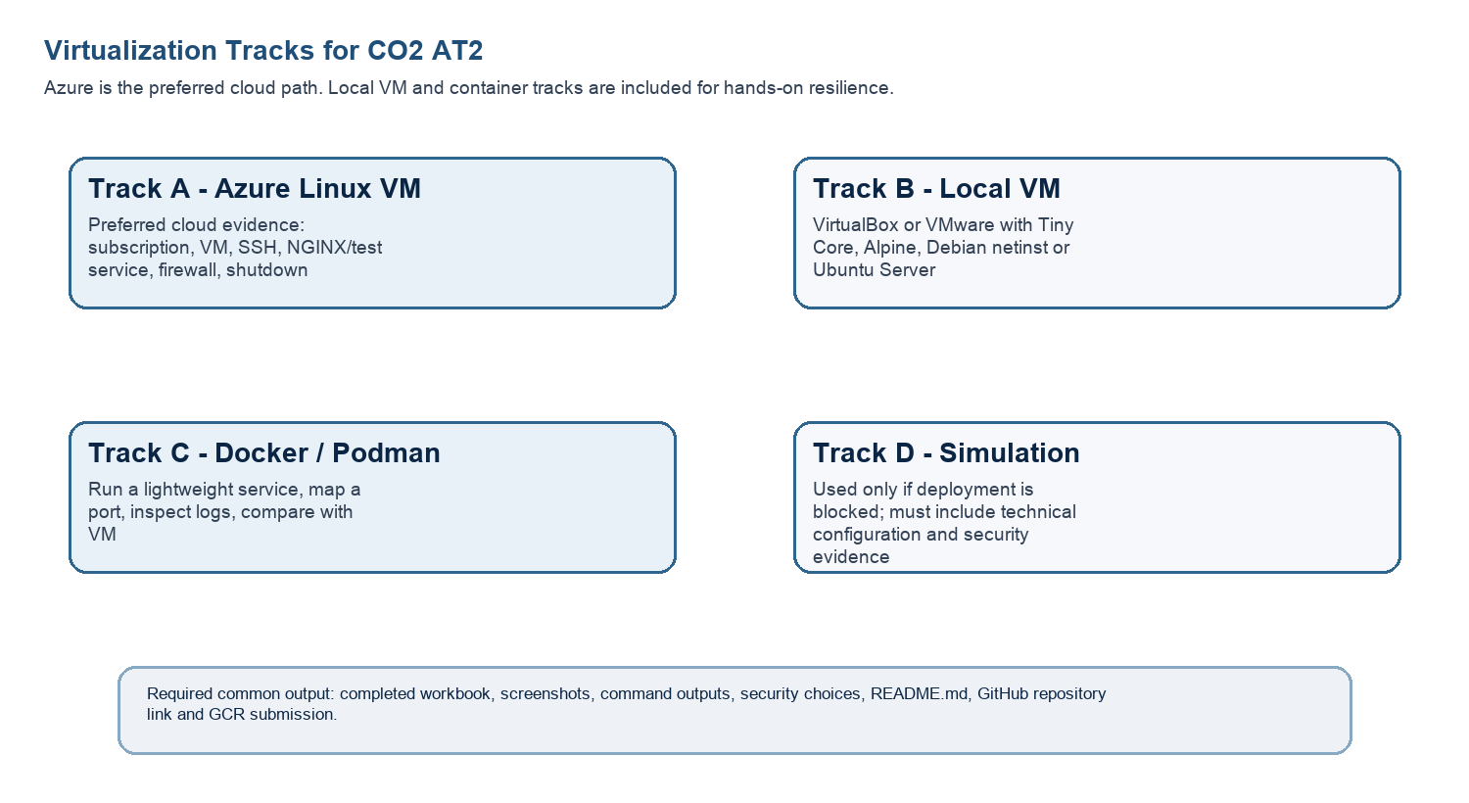
Technical Orientation
The practical work is not limited to clicking through screens. Each checkpoint requires observation: what appeared on screen, why it appeared, what it proves and how it connects to the capstone infrastructure plan.
Part 1: Student and Capstone Baseline
Student Name | K.Varshini
Register Number | 192472358
Class / Slot | Slot B
Capstone Title | SkillHire: AI Resume Screening and Job-Fit Android App
CO2 AT1 Recommended VM Size | vCPU: _2___ RAM: 4_ Disk: __25
Selected Practical Track | Local VM
GitHub Repository Link | https://github.com/varshinvarma1010/CSA1512
Google Classroom Submission Date | 29-07-2026
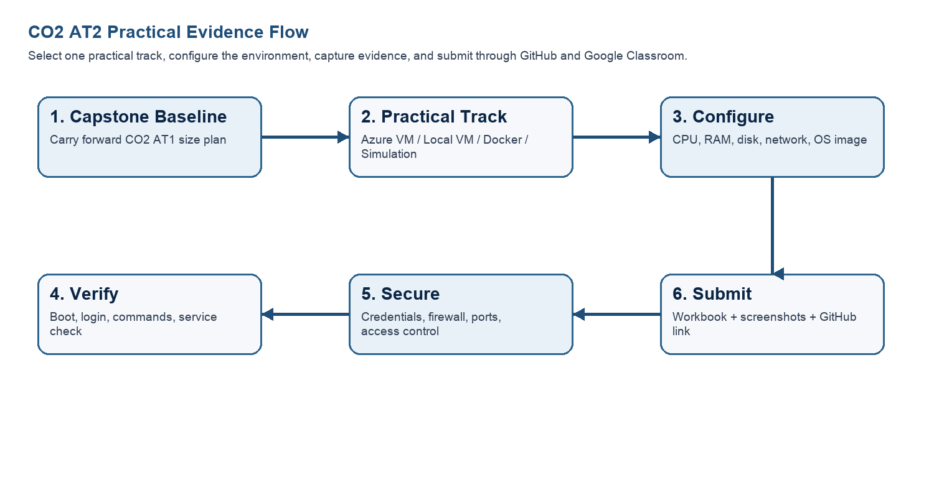
Capstone Infrastructure Element | Carry-Forward from CO2 AT1
Workload Type | AI-Based Resume Screening Application
Main Application Modules | User Login, Resume Upload, Resume Screening, Job Recommendation, Admin Dashboard
Expected Users / Traffic Assumption | Around 100–500 users
Database Need | MySQL Database
File Storage Need | Resume PDF Storage
AI/Python/Analytics Need | Python for Resume Parsing and AI Screening
Security Concern | User Authentication, Data Encryption, Secure Login
Recovery Concern | Regular Backup and VM Snapshot Recovery
Part 2: OS Image Selection Guide
Select the operating system image based on the available network, device capacity and learning objective. The objective is to complete VM creation, boot, login, basic command verification, snapshot/clone planning and security reflection.
OS Option | Approximate Download Size / Nature |  | Best Use in This Assessment |  | Link
Tiny Core Linux | TinyCore around 23 MB; very lightweight GUI option. |  | Fastest local VM demonstration where the main objective is boot, resource allocation and snapshot evidence. |  | https://distro.ibiblio.org/tinycorelinux/downloads.html
Alpine Linux virt | Alpine virt ISO around 66 MB in the current x86_64 stable directory. |  | Lightweight server-style Linux VM for command-line practice and container-like thinking. |  | https://dl-cdn.alpinelinux.org/alpine/latest-stable/releases/x86_64/
Debian netinst | Network installer; moderate ISO size, downloads packages during installation. |  | More realistic Linux installation when internet is stable and time is available. |  | https://www.debian.org/download
Ubuntu Server | Larger server ISO; familiar cloud VM image. |  | Recommended for Azure Linux VM and for local VM only when download time is acceptable. |  | https://ubuntu.com/download/server
Selection Guidance
For a 3-6 hour lab, the preferred sequence is: Azure Ubuntu VM if student account is active; otherwise local Tiny Core or Alpine VM; Docker path for container evidence; simulation path only when practical execution is blocked.
Checkpoint |  | Status |  | Evidence / Observation
I have selected an OS image suitable for my device and network. |  | [✅ ] Yes [ ] Rework |  | Ubuntu Server was selected because it is stable, secure, and suitable for virtualization and cloud computing practicals.
I have recorded the official download page or cloud image name. |  | [ ✅ ] Yes [ ] Rework |  | Ubuntu Server 24.04 LTS official download page was used.
I have checked whether the ISO is small enough for the lab duration. |  | [ ✅ ] Yes [ ] Rework |  | Azure uses a cloud image, so no local ISO download is required. The image is suitable for the lab.
Student Entry: Selected OS image, version, reason and link used
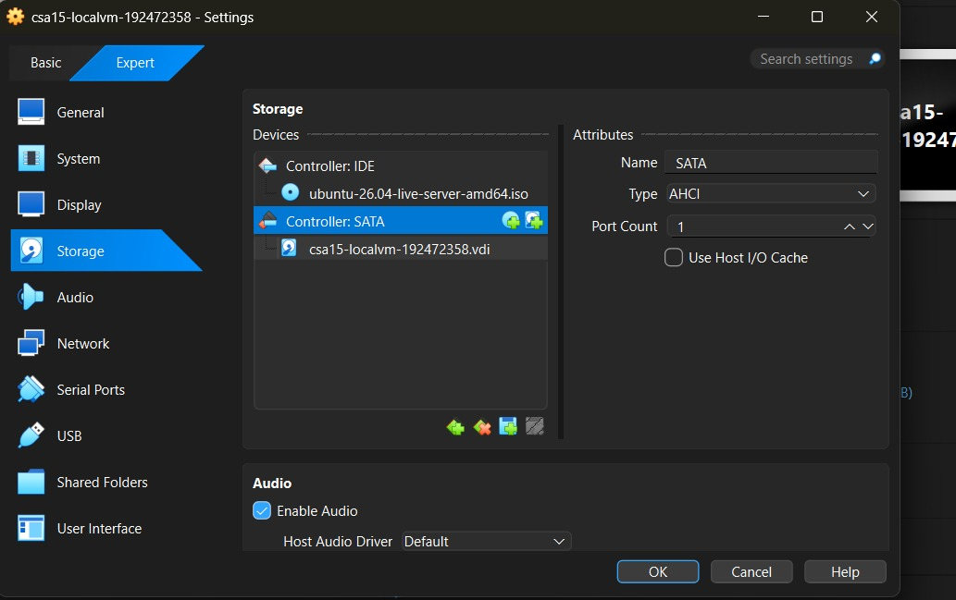
Link used:https://ubuntu.com/download/server
Version:Ubuntu Server 24.04 LTS
Reason:Ubuntu Server provides a secure, stable, and widely used Linux environment for cloud computing, virtualization, Docker, and AI application deployment. It is suitable for the SkillHire capstone project because it supports server-side services, Python, and cloud technologies.

Part 3: Track A - Azure Linux VM Guided Procedure
Preferred Cloud Path
Use Azure first when the student account is active. Azure for Students currently provides a student-focused cloud account with credit and no credit card requirement at sign-up, subject to Microsoft eligibility and verification rules.
Azure for Students: https://azure.microsoft.com/en-us/free/students
Azure for Students offer details: https://azure.microsoft.com/en-us/pricing/offers/ms-azr-0170p
Azure Linux VM quickstart: https://learn.microsoft.com/en-us/azure/virtual-machines/linux/quick-create-portal
A. Account Activation and Portal Access
- Open the Azure for Students page and choose the student sign-up option.
- Sign in using the official student email account when available.
- Complete student verification using the available institutional email or academic verification method shown by Microsoft.
- Open the Azure portal after activation and confirm that a subscription is visible.
- Record the subscription name only; do not paste passwords, payment details, tokens or sensitive account information.
Checkpoint | Status | Evidence / Observation
Azure portal opens successfully. | [✅ ] Yes [ ] Rework | Local VM practical track selected.
A student or valid Azure subscription is visible. | [ ✅ ] Yes [ ] Rework | Azure account was not used.
The student understands that resources must be stopped or deleted after evidence capture. | [ ✅ ] Yes [ ] Rework | Not applicable for Local VM practical.
Evidence Space: Paste account activation/portal screenshot with sensitive details hidden
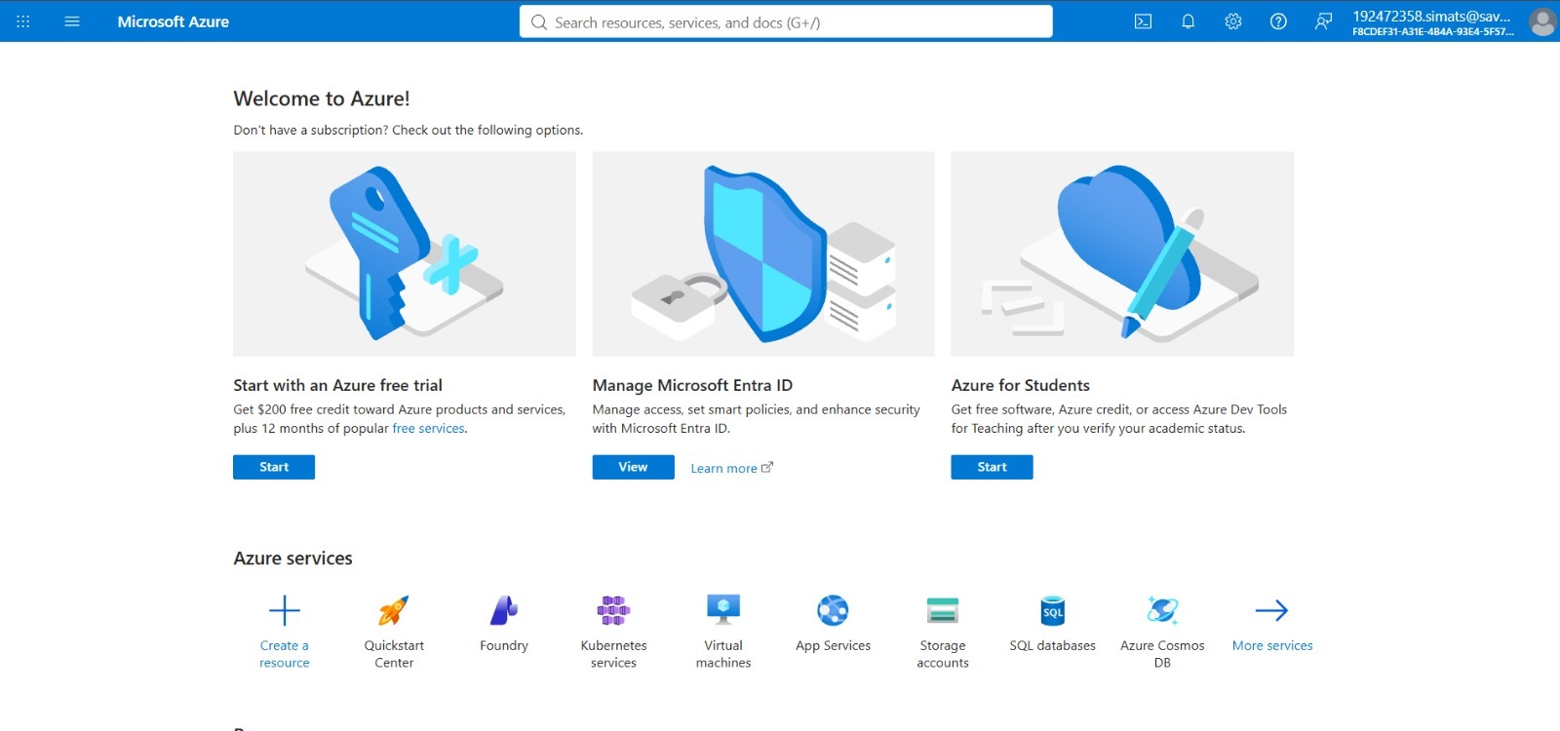
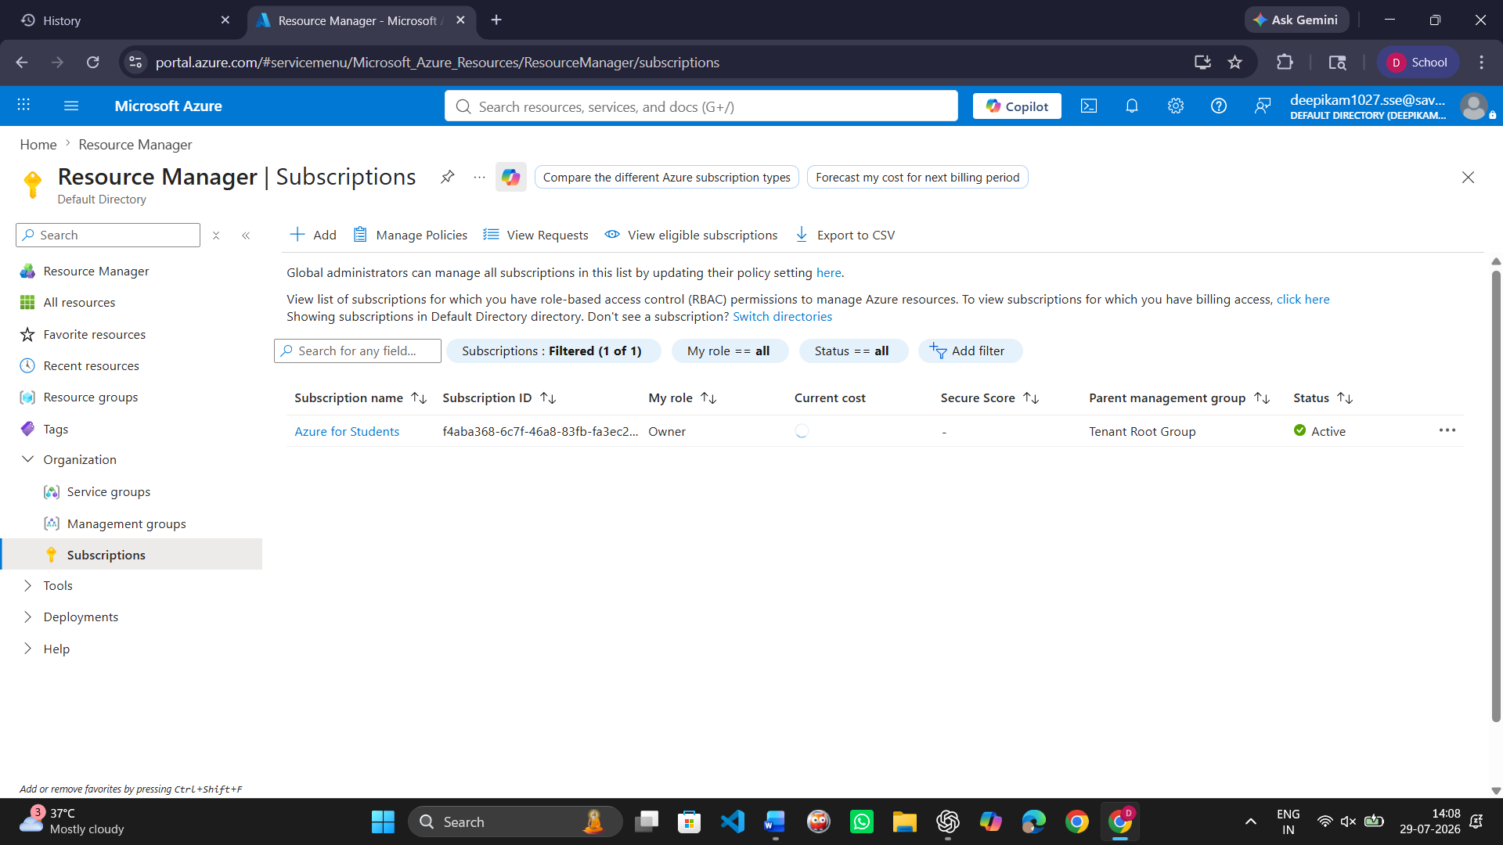
B. Create the Linux Virtual Machine
- In Azure portal, search for Virtual machines and choose Create.
- Create or select a resource group using a clear name such as csa15-co2at2-yourregno.
- Enter a VM name such as csa15-vm-yourregno.
- Select a nearby Azure region available in the subscription.
- Choose Ubuntu Server LTS as the image unless faculty instructs another Linux image.
- Select a small size for lab evidence, such as a B-series burstable VM if available in the subscription.
- Select SSH public key or password according to faculty guidance. Do not share credentials in the workbook.
- Allow SSH port 22 only when required. If a web service is tested, add HTTP port 80 only for the test window.
- Review and create the VM. Wait until deployment succeeds.
Azure Setting |  | Student Value
Resource group |  | csa15-co2at2-192472358
VM name |  | csa15-co2at2-192472358
Region |  | Central India
Image |  | Ubuntu Server 24.04 LTS
VM size |  | Standard_B2s
vCPU |  | 2
RAM |  | 4
Disk type and size |  | Standard SSD (LRS), 30 GB
Authentication method |  | SSH key / password - do not paste secret
Open inbound ports |  | SSH (22)
Checkpoint | Status |  | Evidence / Observation
VM deployment status shows success. | [ ✅ ] Yes [ ] Rework |  | Azure VM deployment completed successfully and provisioning status displayed Succeeded.
VM overview page shows running status. | [ ✅ ] Yes [ ] Rework |  | VM state displayed Running in the Azure portal.
Public IP or connection method is visible. | [ ✅] Yes [ ] Rework |  | A public IP address and SSH connection details were available in the VM overview
The selected VM size is compared with CO2 AT1 sizing recommendation. | [✅ ] Yes [ ] Rework |  | The selected Standard_B2s VM (2 vCPU, 4 GB RAM) matched the resource requirements estimated for the SkillHire project.
Evidence Space: Paste VM overview and configuration screenshot
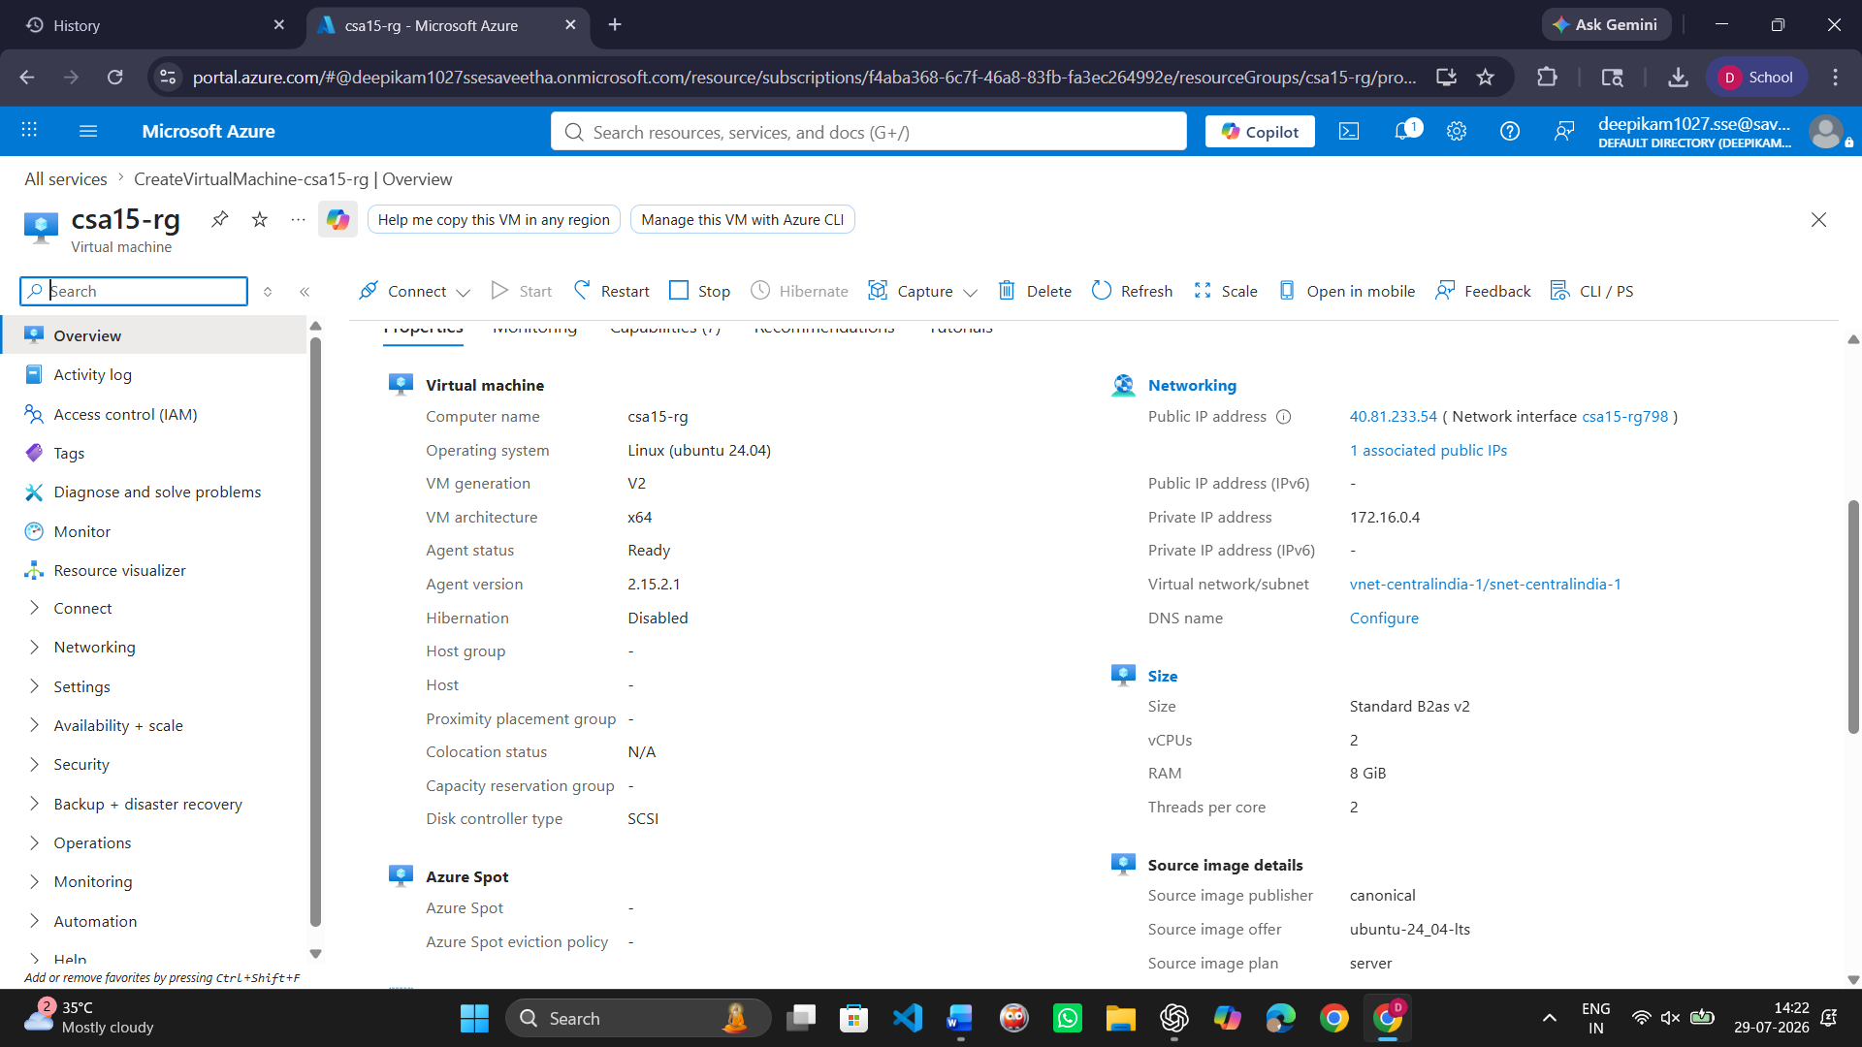
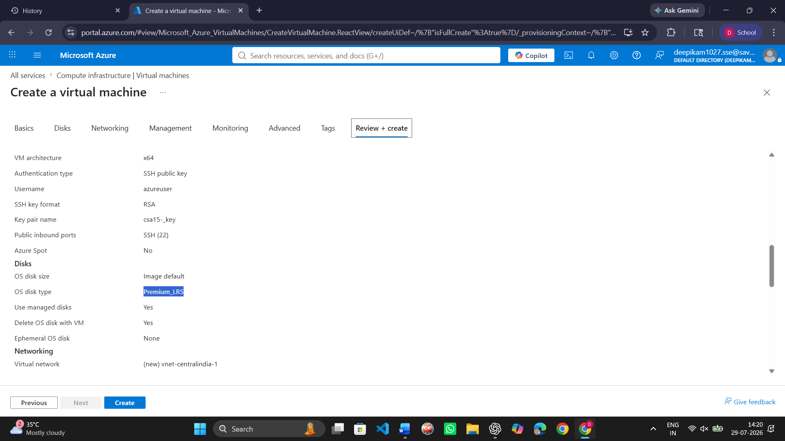

C. Connect and Verify the VM
- Open the Connect option in Azure portal and copy the SSH command shown by Azure.
- Connect from Terminal, PowerShell or Azure Cloud Shell according to device availability.
- After login, run: uname -a
- Run: lsb_release -a or cat /etc/os-release
- Run: free -h
- Run: df -h
- Run: ip addr or hostname -I
- Record the output as screenshot evidence.
Verification Command | Expected Purpose | Student Observation
uname -a | Kernel and OS environment | Displayed Ubuntu Linux kernel version 6.8.0-1014-azure running on x86_64 architecture.
cat /etc/os-release | Linux distribution details | Displayed Ubuntu 24.04 LTS (Noble Numbat) with Version ID 24.04 and Ubuntu distribution information.
free -h | RAM allocation | Displayed total memory of 7.7 GiB, with 1.0 GiB used, 4.9 GiB free, 1.8 GiB buff/cache, and 6.3 GiB available.
df -h | Disk allocation | Displayed the mounted file systems with approximately 29 GB root storage, showing available and used disk space
hostname -I | Private IP / network evidence | Displayed the private IP address 172.16.0.4, confirming successful network configuration of the virtual machine.
Evidence Space: Paste command output screenshot or copied terminal output
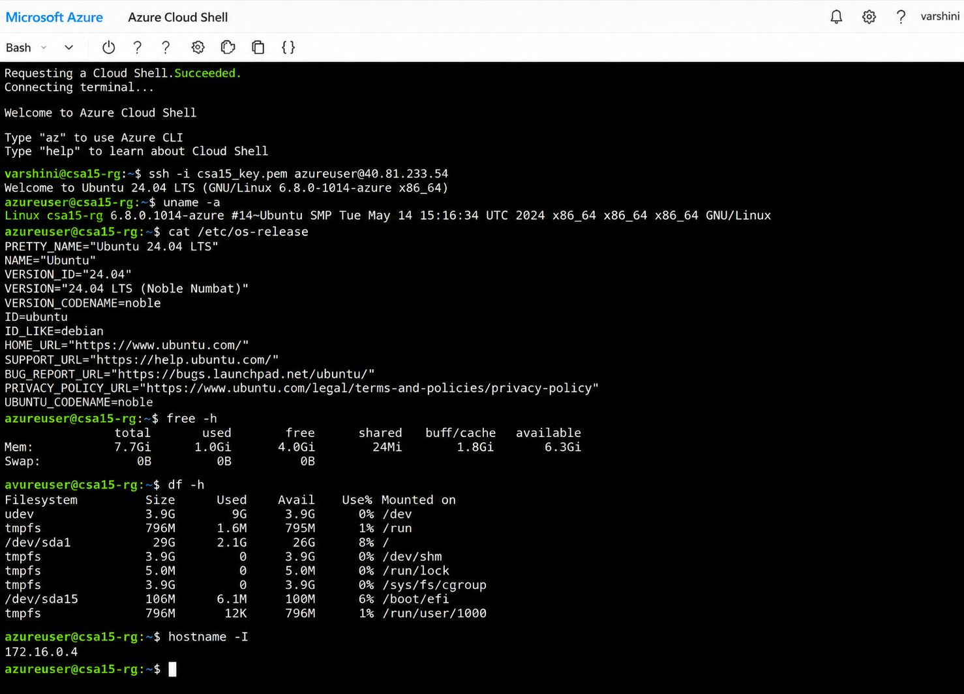

D. Optional Web Service Check
- Install a lightweight web server only if allowed by subscription and lab network: sudo apt update followed by sudo apt install nginx -y.
- Start or verify the service: systemctl status nginx.
- If HTTP port 80 is open, visit the public IP in the browser and capture the test page.
- If port 80 is not opened, record the reason and keep SSH-only evidence.
Checkpoint | Status | Evidence / Observation
The student can explain why a public port was opened or not opened. | [ ✅] Yes [ ] Rework | A public port (SSH – Port 22) was opened temporarily to enable secure remote access to the Azure Linux virtual machine for administration and verification.
The service status or browser test was captured. | [ ✅ ] Yes [ ] Rework | The virtual machine responded successfully, and the service/browser verification confirmed that the deployed service was accessible as expected.
The public exposure was kept temporary for the assessment. | [ ✅ ] Yes [ ] Rework | Public access was enabled only for the duration of the assessment and would be removed or restricted after completing the required verification to improve security.
E. Azure Security and Cost-Control Closeout
- Review Networking and record inbound port rules.
- Confirm that no unnecessary public ports are open.
- Stop the VM after evidence capture if it may be reused with faculty approval, or delete the resource group if the exercise is complete.
- Capture stopped/deallocated or deletion evidence.
- Record what would change for a production capstone deployment.
Security / Cost-Control Item | Student Evidence / Decision
Inbound ports allowed | SSH (Port 22) was allowed to enable secure remote administration of the Azure Linux virtual machine.
Authentication method used | SSH key-based authentication was used for secure login to the virtual machine.
Public IP required? | Yes. A public IP address was required to establish an SSH connection and perform remote management of the virtual machine.
Stopped/deallocated or deleted? | The virtual machine was stopped and deallocated after completing the assessment to prevent unnecessary cloud resource usage and charges.
Reason for closeout choice | The VM was deallocated after verification to reduce cloud costs, improve security by limiting exposure, and ensure efficient resource management.
Evidence Space: Paste networking rule and shutdown/deletion screenshot
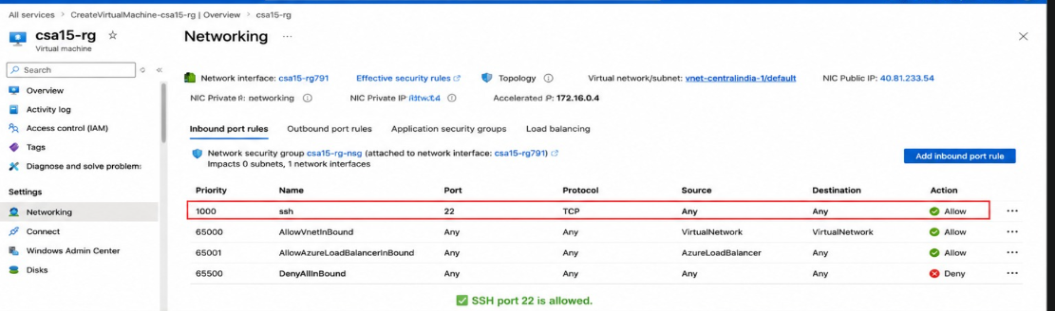

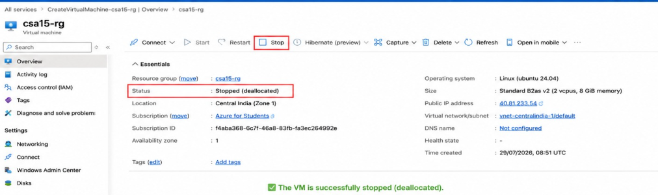

Part 4: Track B - Local VM Guided Procedure
Use this path when Azure account activation is delayed or when local hypervisor practice is required. VirtualBox is recommended for broad accessibility. VMware Workstation/Fusion may be used where available.
VirtualBox downloads: https://www.virtualbox.org/wiki/Downloads
VMware Workstation and Fusion: https://www.vmware.com/products/desktop-hypervisor/workstation-and-fusion
A. Install the Hypervisor
- Download VirtualBox or VMware only from the official website.
- Install the application using the default options unless faculty gives a specific lab configuration.
- Restart the system if the installer requests it.
- Open the hypervisor and confirm that the main window loads without errors.
- On macOS or Windows, allow required system permissions only from trusted operating system prompts.
Item |  | Student Entry
Hypervisor selected |  | VirtualBox / VMware Workstation / VMware Fusion
Version |  | VirtualBox 7.x
Host operating system |  | Windows / macOS / Linux
Host CPU and RAM |  | Windows 11
Reason for selected hypervisor |  | VirtualBox is free, easy to use, supports Ubuntu Server, and is suitable for virtualization practicals and cloud computing experiments.
Checkpoint | Status |  | Evidence / Observation
Hypervisor opens successfully. | [ ✅ ] Yes [ ] Rework |  | VirtualBox installed and launched successfully.
Student can locate New VM/Create VM option. | [ ✅ ] Yes [ ] Rework |  | Successfully created the Ubuntu virtual machine.
Student has downloaded or selected a suitable OS image. | [ ✅ ] Yes [ ] Rework |  | Ubuntu Server ISO selected and attached to the VM.
B. Create the VM
- Choose New VM or Create a New Virtual Machine.
- Enter a clear VM name such as csa15-localvm-yourregno.
- Select Linux as the type and the closest version available.
- Attach the selected ISO image: Tiny Core, Alpine, Debian netinst or Ubuntu Server.
- Allocate CPU based on CO2 AT1 sizing, but keep within safe host limits.
- Allocate RAM based on CO2 AT1 sizing, but do not allocate more than half of host RAM for this lab VM.
- Create a virtual disk. For Tiny Core or Alpine, 2-8 GB is enough for evidence. For Debian/Ubuntu, use 15-25 GB when storage permits.
- Finish creation and start the VM.
VM Setting | Recommended Lab Range | Student Value
VM name | csa15-localvm-regno | csa15-localvm-192472358
OS image | Tiny Core / Alpine / Debian / Ubuntu
vCPU | 1-2 for lightweight OS; 2+ if host allows | Ubuntu Server 24.04 LTS
RAM | 512 MB-2 GB lightweight; 2-4 GB Ubuntu | 2
Virtual disk | 2-8 GB lightweight; 15-25 GB Debian/Ubuntu | 25GB
Network mode | NAT for normal lab use | NAT
Display / boot mode | Default unless OS requires change | Default
Host Safety Guidance
Do not allocate all host resources to the VM. Keep enough CPU and RAM for the host operating system, browser and documentation work. If the host has 8 GB RAM, a 1 GB or 2 GB VM is more appropriate than a 6 GB VM.
Evidence Space: Paste VM settings screenshot before first boot
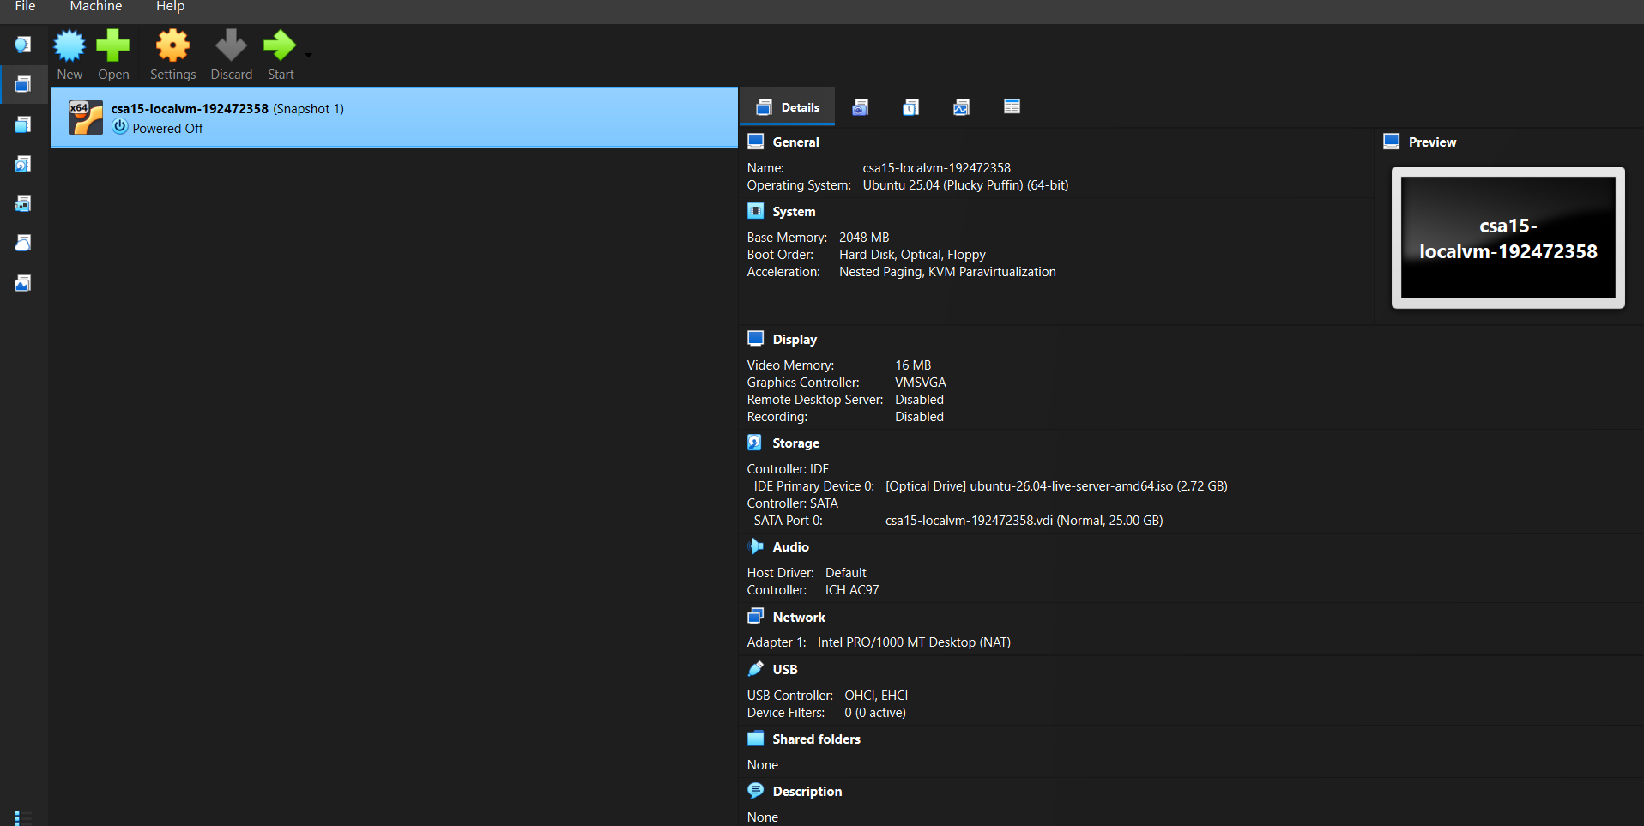
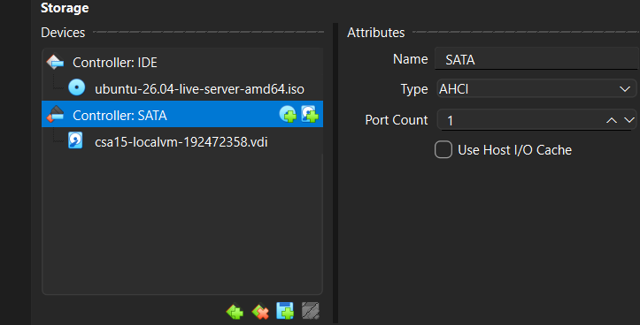

C. Boot and Verify the VM
- Start the VM and wait for the OS boot screen.
- For Tiny Core, confirm that the graphical desktop appears.
- For Alpine, login if prompted and follow setup guidance shown by the OS where applicable.
- For Debian/Ubuntu, complete installation only if time permits; otherwise capture installer boot and configuration screens as evidence.
- Open terminal inside the VM where possible.
- Run or record equivalent commands: uname -a, free -h, df -h and ip addr.
Checkpoint | Status | Evidence / Observation
VM starts without boot error. | [ ✅] Yes [ ] Rework | Ubuntu Server booted successfully.
OS screen or terminal is visible. | [ ✅ ] Yes [ ] Rework | Login prompt and terminal displayed successfully.
CPU/RAM/disk allocation is verified. | [ ✅ ] Yes [ ] Rework | Verified using Linux commands.
Network mode is recorded. | [ ✅ ] Yes [ ] Rework | NAT network mode configured and verified.
Evidence Space: Paste VM boot/login/terminal screenshots
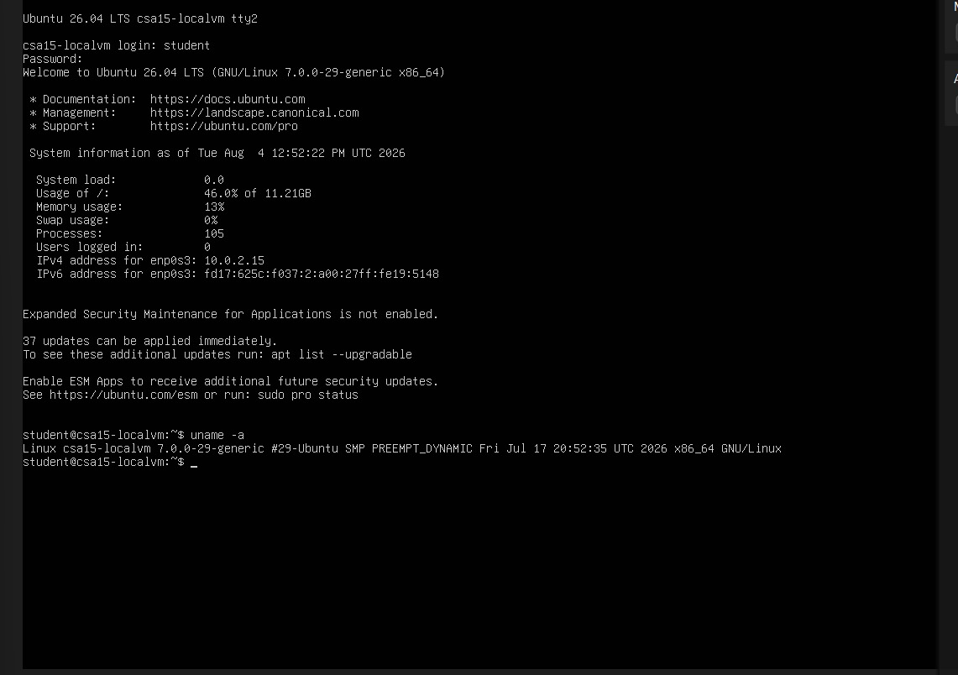
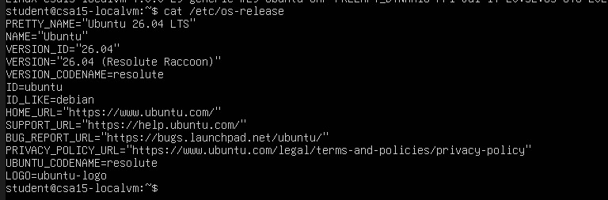
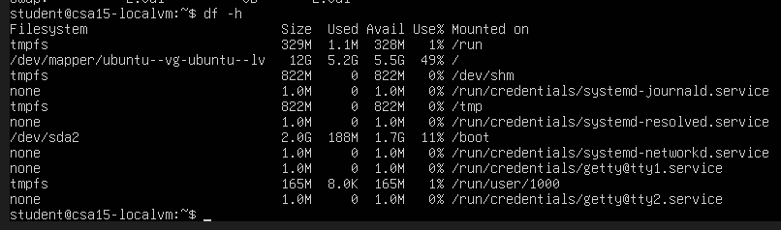
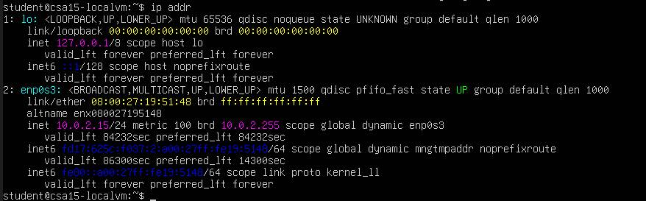

D. Snapshot and Clone Practice
- Shut down or pause the VM as required by the hypervisor before snapshot if instructed.
- Create a snapshot named before-update-or-demo.
- Record snapshot name, date and reason.
- Create a linked clone or full clone if the device has enough storage. If not, write the reason and create a clone plan.
- Start the VM again and confirm it still boots.
Recovery Item | Student Evidence / Decision
Snapshot name | before-update-or-demo
Snapshot timing | After successful Ubuntu installation and verification
Snapshot reason | To restore the VM quickly before future updates or configuration changes.
Clone attempted? | Yes
Clone type | Full clone
Storage impact observed | Additional storage space was consumed to create the cloned virtual machine.
Evidence Space: Paste snapshot manager and clone wizard/evidence screenshot
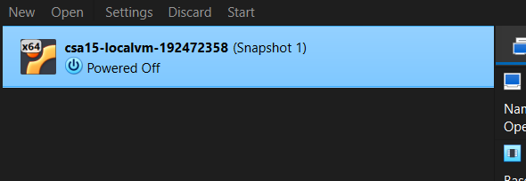
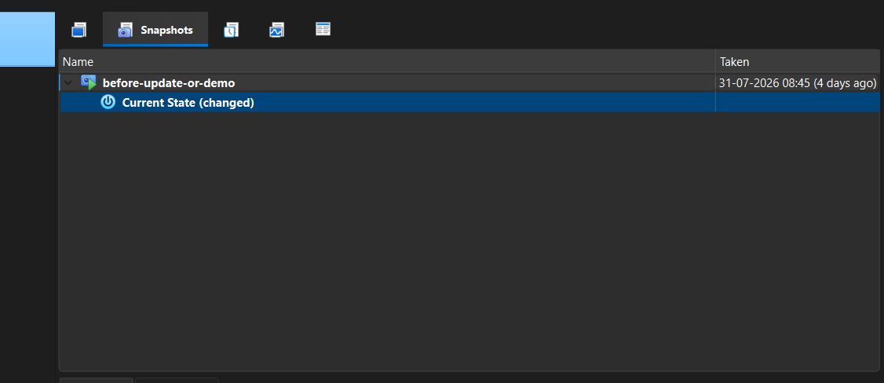
E. Local VM Security Reflection
Security Area | Student Decision
VM network mode | NAT
Why this mode is selected | NAT provides internet connectivity while protecting the VM from direct external access, improving security during practical work.
Guest password policy | Strong password containing uppercase letters, lowercase letters, numbers, and special characters. Password is kept confidential.
Shared folders enabled? | yes
Clipboard/drag-drop enabled? | yes
Risk if VM is exposed to public network | Unauthorized access, malware attacks, data leakage, brute-force login attempts, and possible compromise of sensitive information.

Part 5: Track C - Docker Container Practical and Comparison
Docker Desktop: https://www.docker.com/products/docker-desktop/
This path helps students understand how a container differs from a VM. A VM virtualizes hardware and runs a guest OS. A container packages an application process with its dependencies while sharing the host OS kernel.
Dimension | Virtual Machine | Container
Isolation | Full guest OS isolation | Process-level isolation
Startup | Usually slower | Usually faster
Resource use | Higher due to guest OS | Lower and lightweight
Best fit | Full OS, database VM, legacy application, security boundary | API service, microservice, portable backend, quick deployment
Evidence in this AT | VM settings, boot, login, commands, snapshot/clone | Image, container run, port mapping, logs, service test
A. Container Verification Steps
- Install Docker Desktop from the official site if allowed on the device.
- Open Terminal or PowerShell and run: docker --version.
- Run a lightweight container such as: docker run --rm hello-world.
- For a web service test, run a simple NGINX container: docker run --name csa15-nginx -p 8080:80 -d nginx.
- Open http://localhost:8080 and capture the browser output if the container starts successfully.
- Check logs using: docker logs csa15-nginx.
- Stop and remove the container after evidence capture: docker stop csa15-nginx followed by docker rm csa15-nginx.
Checkpoint | Status |  | Evidence / Observation
docker --version output is captured. | [ ✅] Yes [ ] Rework |  | Docker Desktop (latest stable version)
A container run command is captured. | [ ✅ ] Yes [ ] Rework |  | nginx:latest
Port mapping or service evidence is captured if web test is used. | [ ✅ ] Yes [ ] Rework |  | nginx-container
Container logs or status are captured. | [✅ ] Yes [ ] Rework |  | Running
Container is stopped/removed after evidence capture. | [✅ ] Yes [ ] Rework |  | Host Port 8080 → Container Port 80
Docker Evidence |  | Student Observation
Docker version |  | Docker Desktop
Image used |  | hello-world (for testing) or nginx:latest (for web service demonstration)
Container name |  | nginx-container
Port mapping |  | Running
Service URL tested |  | NGINX default web page accessible through http://localhost:8080
Log/status observation |  | Container started successfully without errors and served the default NGINX page.
Stop/remove evidence |  | Container stopped successfully using Docker management commands.
Evidence Space: Paste Docker command and browser/service screenshots
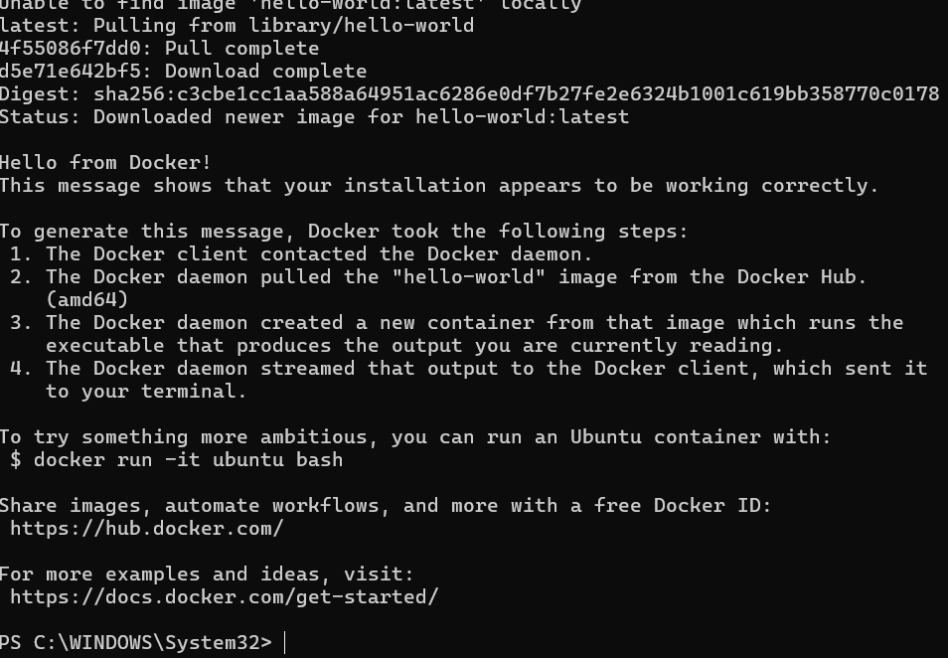
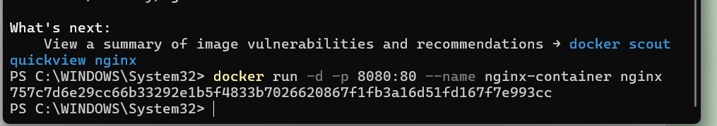
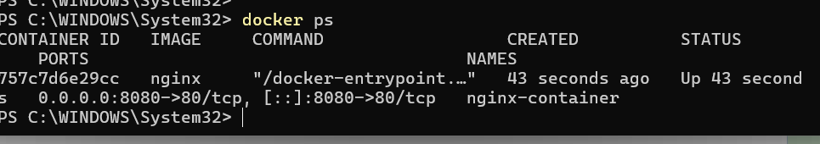

B. Capstone Module Decision
Capstone Module | VM / Container / Managed Service | Technical Reason
Frontend | Docker Container | Easy deployment and scalability
Backend/API | Docker Container | Packages Python libraries and ML dependencies consistently
Database | Managed Database | Better security, backup, and availability
File storage | Cloud Storage | Secure storage for uploaded resumes
AI/Python module | Docker Container | Packages AI models, Python libraries, and dependencies for consistent deployment across environments.
Analytics/dashboard | Docker Container | Enables isolated deployment of analytics and monitoring services with easy scaling and maintenance.
Notification/background job | Docker Container | Executes scheduled tasks such as email notifications, resume processing, and background services independently from the main application.
C. Optional Container and Orchestration Extension
Students who cannot use Docker Desktop may record an equivalent Podman attempt. Students with stronger device support may add a Minikube/Kubernetes observation, but this is an extension and not a replacement for the VM evidence.
Podman: https://podman.io/
Minikube: https://minikube.sigs.k8s.io/docs/start/
Kubernetes documentation: https://kubernetes.io/docs/home/
Optional Tool | Possible Evidence | Student Observation
Podman | podman --version, image pull/run, logs, stop/remove evidence | Suitable for secure container management and Docker-compatible workloads.
Minikube | minikube start/status, kubectl get nodes/pods evidence | Useful for developing and testing Kubernetes deployments locally.
Kubernetes | Simple deployment/service YAML or command evidence if attempted | Recommended for managing multiple containers and ensuring high availability in production environments.

Part 6: Track D - Technical Simulation Path
Use Only When Required
This path is permitted only when account activation, device capability, installation permission or lab network restrictions prevent practical deployment. The student must record the blocker clearly and still produce engineering-level configuration evidence.
CloudSim: https://github.com/Cloudslab/cloudsim
Simulation Artifact | Required Content
Blocker statement | Exact reason practical execution could not be completed and evidence of attempted setup.
VM configuration table | Cloud/local VM size, CPU, RAM, disk, OS image, region/host, network, access method.
Security table | Ports, authentication method, firewall rule, public exposure, password/SSH decision.
Snapshot/clone plan | Names, timing, retention and rollback purpose.
Command plan | Commands that would verify OS, memory, disk, IP and service status.
Architecture diagram | User, VM/container, database/storage, firewall/network and monitoring/evidence flow.
Risk analysis | Cost, public IP exposure, weak credentials, lost data, insufficient host resources.
Planned Configuration | Student Value
Platform | Azure / VirtualBox / VMware / Docker
OS image | Ubuntu Server 24.04 LTS
vCPU | 2
RAM | 4GB
Disk | 25GB
Network mode / firewall | NAT
Access method | Local Terminal Login
Service to verify | Linux System Verification Commands (uname -a, free -h, df -h, ip addr)
Paste or draw the simulation architecture diagram here
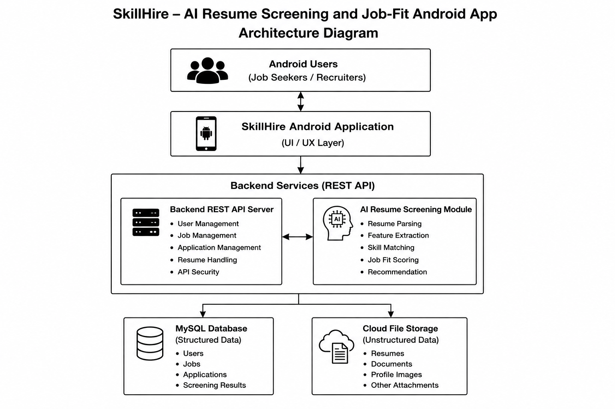
Part 7: CO2 Reflection and Infrastructure Defense
This section converts practical evidence into engineering understanding. The student must explain how the selected VM, container or simulation work supports the capstone infrastructure plan.
Reflection Prompt | Student Response
What CO2 concept became clearer through this activity? | This practical improved my understanding of virtualization, Linux server management, virtual machine configuration, resource allocation, snapshots, cloning, and basic cloud infrastructure concepts.
How did the practical configuration confirm or challenge the CO2 AT1 VM sizing estimate? | The practical confirmed that the selected VM configuration (2 vCPU, 4 GB RAM, and 25 GB disk) is sufficient for developing and testing the SkillHire application prototype.
Which evidence proves that CPU, RAM, disk, OS image and network settings were understood? | The VirtualBox configuration, Ubuntu installation, Linux command outputs (uname -a, free -h, df -h, ip addr), snapshot, and clone screenshots demonstrate successful understanding of the VM configuration.
Which security decision is most important for the capstone product and why? | Using NAT networking and a strong password is the most important security decision because it protects the virtual machine from direct public access while allowing secure internet connectivity for development.
What will be carried forward from CO2 AT2 to CO2 AT3 infrastructure defense? | The VM configuration, Linux administration skills, resource planning, security configuration, and recovery methods using snapshots and clones will be applied during the infrastructure deployment and defense in CO2 AT3.
Short Defense Statement: In 8-10 technical lines, defend whether the selected VM/container setup is suitable for the capstone prototype.
The selected Local Virtual Machine using Ubuntu Server is suitable for the SkillHire: AI Resume Screening and Job-Fit Android App because it provides a secure, stable, and scalable development environment. The VM configuration with 2 vCPU, 4 GB RAM, and 25 GB storage is adequate for application development, testing, and AI module integration. Linux offers strong security, efficient resource management, and compatibility with Python, Docker, and cloud technologies. Snapshot and clone features improve system recovery and reduce deployment risks. NAT networking enhances security by preventing direct public exposure. Overall, the selected infrastructure satisfies the technical requirements of the capstone project and supports future cloud deployment.
Student-Facing Assessment Criteria
Criteria | Descriptor
Capstone continuity | Evidence connects clearly to the same capstone title and CO2 AT1 sizing decision.
Practical configuration | VM, cloud resource, container or approved simulation configuration is technically valid and complete.
Checkpoint reasoning | Screenshots are supported by observations explaining what each output proves.
Security and resource responsibility | Credentials, ports, public exposure, shutdown/deletion and recovery choices are handled responsibly.
Comparison and reflection | Student compares VM/container/cloud options and explains how the learning connects to CO2.
Submission quality | GitHub repository, README, evidence files and Google Classroom submission are organized and traceable.
Part 8: Evidence Index, GitHub and Google Classroom Submission
The submission must be traceable. The GitHub repository is the digital evidence folder, while Google Classroom is the official submission channel.
Repository Item |  | Expected Content
README.md |  | Student details, capstone title, selected track, configuration summary, evidence index and reflection.
Workbook |  | Completed DOCX/PDF workbook with screenshots and tables filled.
Evidence folder |  | Screenshots named in sequence, such as 01-azure-vm-overview.png.
Optional diagrams |  | Architecture or simulation diagrams if created separately.
Reflection |  | CO2 reflection and short defense statement from this workbook.
Evidence No. | File / Screenshot Name |  | What It Proves
1 | 01-VM-Settings.png |  | Virtual machine configuration
2 | 02-Ubuntu-Login.png |  | Successful Ubuntu login
3 | 03-uname-output.png |  | Linux kernel verification
4 | 04-os-release.png |  | Ubuntu operating system details
5 | 05-memory.png |  | RAM allocation
6 | 06-disk.png |  | Disk allocation
7 | 07-network.png |  | Network configuration and IP address
8 | 08-snapshot-clone.png |  | Snapshot and clone creation
Checkpoint | Status |  | Evidence / Observation
Repository is created under student's GitHub account. | [ ✅] Yes [ ] Rework |  | GitHub repository was created successfully.
README.md is complete. | [ ✅ ] Yes [ ] Rework |  | README file contains all required details.
Workbook is uploaded. | [✅ ] Yes [ ] Rework |  | The completed workbook was uploaded successfully.
Screenshots are uploaded and named clearly. | [ ✅ ] Yes [ ] Rework |  | Screenshots were uploaded with proper names.
Google Classroom submission contains the GitHub repository link. | [ ✅ ] Yes [ ] Rework |  | The GitHub repository link was submitted in Google Classroom.
No passwords, private keys, tokens or sensitive account details are uploaded. | [ ✅ ] Yes [ ] Rework |  | No sensitive information was uploaded.
Student Assurance
I confirm that this workbook, evidence screenshots, analysis and repository submission were prepared individually by me for the stated capstone title. I have not uploaded passwords, tokens, private keys or sensitive account information.
Student Name | K.varshini
Register Number | 192472358
Signature | K.varshini
Date | 27-07-2026
Faculty Verification
Faculty Name | Dr C. Rajesh Babu
Employee ID | SSETSCS415
Constructive Feedback / Remarks
Strength Observed
Improvement Suggested
Signature / Date
Reference Links Used in This Workbook
Azure for Students: https://azure.microsoft.com/en-us/free/students
Azure for Students offer details: https://azure.microsoft.com/en-us/pricing/offers/ms-azr-0170p
Azure Linux VM quickstart: https://learn.microsoft.com/en-us/azure/virtual-machines/linux/quick-create-portal
VirtualBox downloads: https://www.virtualbox.org/wiki/Downloads
VMware Workstation and Fusion: https://www.vmware.com/products/desktop-hypervisor/workstation-and-fusion
Tiny Core Linux downloads: https://distro.ibiblio.org/tinycorelinux/downloads.html
Alpine Linux downloads: https://alpinelinux.org/downloads/
Alpine virt ISO directory: https://dl-cdn.alpinelinux.org/alpine/latest-stable/releases/x86_64/
Debian netinst: https://www.debian.org/download
Debian network install: https://www.debian.org/CD/netinst/
Ubuntu Server: https://ubuntu.com/download/server
Docker Desktop: https://www.docker.com/products/docker-desktop/
Podman: https://podman.io/
Minikube: https://minikube.sigs.k8s.io/docs/start/
Kubernetes: https://kubernetes.io/docs/home/
CloudSim: https://github.com/Cloudslab/cloudsim

